**STRESS DETECTION AND REDUCTION IN IT PROFFESIONAL**

**A FINAL YEAR PROJECT REPORT**

**Submitted By**

|  |  |
| --- | --- |
| **Sreekrishna PA** | **181001093** |
| **Srimanjey R** | **181001095** |

**Sugumaran B 181001102**

**in partial fulfillment for the completion of the**

**FINAL YEAR PROJECT REPORT**



**APRIL 2022**

**RAJALAKSHMI ENGINEERING COLLEGE,THANDALAM CHENNAI – 600 025**

**BONAFIDE CERTIFICATE**

Certiﬁed that this project report **“STRESS DETECTION AND REDUCTION IN IT PROFFESIONAL”** is the bonaﬁde work of **SREEKRISHNA P A (181001093),SRIMANJEY R (181001095),SUGUMARAN B (181001102)** who carried out the project work under my supervision. Certiﬁed further that to the best of my knowledge the work reported herein does not form part of any other thesis or dissertation on the basis of which a degree or award was conferred earlier occasion on this or any other candidate.

SIGNATURE SIGNATURE

# Dr SHAKTHIVALAN S DR.KAYALVIZHI HEAD OF THE DEPARTMENT MENTOR

Professor Assistant Professor [SS]

Information technology, Information technology, Rajalakshmi Engineering College, Rajalakshmi Engineering College, Thandalam, Thandalam,

Chennai – 602105. Chennai – 602105.

# EXTERNAL EXAMINER INTERNAL EXAMINER

**ACKNOWLEDGEMENT**

We thank the Almighty God for the successful completion for the project. Sincere thanks to our Chairman **Mr. S. Meganathan** for his sincere endeavor in educating us in his premier institution.

We thank our chairperson **Dr. (Mrs.) Thangam Meganathan** for her motivation and inspiration that paved for the completion of our project.

We also express our gratitude to our principal **Dr. S. N. Murugesan** who helped us in providing the required facilities in completing the project.

We would like to thank our Head of Department **Dr. Shakthivelan** for her guidance and encouragement for completion of the project.

We would like to thank **DR.Kayalvizhi S,** our supervisor for constantly guiding us and motivating us throughout the course of the project. We express our gratitude to our parents and friends for extending their full support to us.

# ABSTRACT

Nowadays, IT industries are  developing at a rapid pace in the market by  introducing new technologies and deadlines and it  requires its employees to cope up with its pace which  leads to stress. This develops stress within its  employees making them less effective. Hence this study aims to develop a system to detect the stress  level of IT professionals and provide them with  remedies to reduce stress. The system monitors the  facial emotions of the employees at real-time through  webcam and it uses the mini-Xception model of the  CNN algorithm to identify the emotions of the  employee and classifies them. When an employee is  classified as „stressed‟ the system calculates the stress  level of the employees by providing questionnaire  and displacement of eyebrow from its mean position.  Based on the computed stress level of the employee  the system provides remedies such as playing classic  music, offering to meditate, play stress reduction  games, meditate for a few minutes, provide food  coupons to the employees, and participation in sports  activities. The dataset used is FER-2013 dataset that  has approximately 30000 images to train the system.  The achieved accuracy of the system is 95.6%. This  stress detection and reduction system can also be  applied to other industries such as banking sector,  mechanical industries. This system helps in reducing  stress in employees and thereby promoting a healthy  work environment and work culture making the  employees to stay motivated, focused and efficient.

**KEYWORDS:**

Convolutional Neural Network, facial  emotion, mini-Xception.

# TITLE OF CONTENTS

**TITLE PAGE NO**

ABSTRACT 04

LIST OF FIGURES 07

LIST OF SYMBOLS 08

LIST OF ABBREVIATIONS 09

1. INTRODUCTION
   1. SYSTEM OVERVIEW 10
   2. SCOPE OF THE PROJECT 13
2. LITERATURE SURVEY
   1. RELATED WORKS 14
   2. CONCLUSION 21
3. PROPOSED SYSTEM DESIGN
   1. INTRODUCTION 23
   2. PROPOSED SYSTEM
   3. Convolutional Neural Network
   4. Trained Dataset
   5. SYSTEM ARCHITECTURE

3.31 USECASE

# SYSTEM IMPLEMENTATION

* 1. REQUIREMENT SPECIFICATION
     1. HARDWARE REQUIREMENTS 26
     2. SOFTWARE SPECIFICATION 26
  2. ALGORITHM OF OVERALL PROCESS 27

# RESULT ANALYSIS 33

# CONCLUSION

* 1. CONCLUSION 36
  2. FUTURE WORK 37

# APPENDIX REFERENCES

6

LIST OF FIGURE

|  |  |
| --- | --- |
| ARCHITECHTURE DIAGRAM |  |
| USECASE DIAGRAM |  |
| TRANINED DATASET |  |
| Convolutional Neural Network |  |
|  |  |

LIST OF ABBREVIATIONS

1. CNN - CONVOLUTIONAL NEURAL NETWORK
2. FER Model – Facial Emotion Recognition

# CHAPTER 1 INTRODUCTION

* 1. SYSTEM OVERVIEW

The project is about stress detection and reduction for IT professionals. The system that recognize the user input using mini-Xception in Convolutional Neural Network (CNN).To recognize the stress detection and reduction on computer using webcam. Therefore, we are designing a system that can daily record a person’s stress level and time and help the user with regulated breathing as a way of reducing their momentary stress. We can detect the stress and reduce through playing a music, play games, providing food coupons and take a rest of the day because of stress reduction.

Stress management systems play a major role to notice the stress levels that disrupts our socio-economic mode. As World Health Organization (WHO) says, Stress may be a psychological state drawback moving the lifetime of one in four voters. Human stress results in mental furthermore as socio-fiscal issues, lack of transparency in work, poor operating relationship, depression and eventually commitment of suicide in severe cases.

* 1. OBJECTIVE

Our goal is to create and combine a continuous monitoring device and stress management device into one system. Our continuous monitoring device will be responsible for monitoring the user’s stress level, so that the user will be able to concentrate on his/her tasks throughout the day and be assured that stress levels are accounted for. We will also help the user regulate his breathing to relieve any stress that is detected and reduce the stress level and make his/her health level. In this system a real-time non-intrusive video are captured, which detects the emotional status of a person by analyzing the facial expression. It detects an individual emotion in each video frame and the decision on the stress level is made in sequential hours of the video captured. The system employs a technique that allows system to train a model and analyze differences in predicting the features. The main objective of the system the IT employees are feel free to work and stress free which is the ultimate goal of the project.

* 1. CONCLUSION

There are many stress level detection is projects are implemented and published to detect the stress level using sensors, smart watch, EEE signals. But our system model is based on complete software oriented stress detection and reduction by using webcam the individual can monitored and detect the stress level by coordinates of the eye and the trained dataset can compare the trained dataset with live coordinates of eye and determine the stress level based on the stress level and provide the remedies according to the level of stress. The image is captured automatically when the authenticate user is logged in based on some time interval. The captured images are used to detect the stress of the user based on some standard conversion and image processing mechanisms. Then the system will analyze the stress levels by using Machine Learning algorithms which generates the results that are more efficient.

* 1. INTRODUCTION

# CHAPTER 2 LITRATURE SURVEY

Daily life stress is an important problem of our modern society. It is a growing issue and it has become an unavoidable part of our daily lives. Psychological stress types can be listed as acute and chronic . Acute stress is more prevalent than chronic stress. American Psychological Association noted that the causes of acute stress are pressure from recent past and near future . Athletic challenges, test taking, or anxiety when meeting new people can induce acute stress. On the other hand, long-standing pressures and demands as a result of socioeconomic conditions, difficulties in interpersonal relationships, or an unsatisfying career can trigger chronic stress. If chronic stress is not handled properly, it could result in serious health issues . Since symptoms of acute stress are more apparent than chronic stress symptoms, acute stress is more widely investigated.

After musculoskeletal illnesses, which also could be stress-related in some cases , stress is one of the most significant health problems in the world. The effect of stress on human health depends on the stress type. Emotional distress, muscular ache and tension, back pain, headache, heartburn, digestive tract issues, and overarousal can be named as the effects of acute stress . Overarousal can cause heart attacks, arrhythmias, and even sudden death for people with heart conditions . Effects of the chronic stress on human health are akin to those of acute stress however it can damage physical conditions more. Possible causes of the chronic stress can be listed as hypertension and coronary disease , irritable bowel syndrome, gastroesophageal reflux disease , generalized anxiety disorder, and depression . The above-mentioned stress-related diseases also affect the economy by increasing absenteeism, staff turnover , presenteeism, and tardiness. These problems decrease the production and increase the work-related costs. Public surveys unveiled that at least half of the European workers are subjected to stress at work. Furthermore, at least half of the lost working days in the business sector are assumed to be caused by work-related stress and psycho-social risks .

Researchers found out that stress should be handled when the symptoms first come out to avoid the long-term consequences. In other words, stress must be discovered in early stages to refrain from more damages and impede it from being chronic. The above-mentioned damages of stress on human health and detriments to social life and economy have forced researchers to come up with an automatic stress monitoring scheme which exploits smart wearable devices and advanced affective computing algorithms. This scheme can be applied in automobiles, airplanes, factories, and offices, at job interviews and daily life environments. This scheme can further compute social stress stages during meetings or mutual intercommunication. The ideal scheme should be applicable to daily life, i.e., it should use unobtrusive sensors and devices which users can wear easily in their daily routines. In this work, we developed an stress level detection scheme that uses face recognition from co-ordinates of eye. Our scheme can also be applied to daily life of IT professionals . In real-life settings, movements of individuals are unrestricted and artifacts occur because of that. In order for our system to be applicable in these settings, we applied several novel artifact detection and removal strategies. These artifact detection algorithms are developed for specific algorithm and their performances are scientifically proven. We further extracted features from the remedies of stress reduction with our system. From these features, we classified the stress level of an individual by employing machine learning algorithms. To test our system in real-life settings, we collected physiological signals of participants in an algorithmic programming summer camp via co-ordinates of the eye of an individual.

[1] This study focuses on developing a system for predicting depression using feed – forward neural  network model and uses depression scale to measure  the depression level. Calculating the improvement  level is based on the depression levels identified and  is visually represented in a dashboard to monitor  depression level improvements for the therapist and  the patient. The main aim is to provide a solution for  Youths who require therapy for depression. The  proposed Solution consists of a mobile app which  will assist the clients .Then the therapist engage with  the online and monitor them. The improvement level of depression of client is recorded on each therapy  Session. The FFNN is trained through back  propagation by comparing the output Predicted and  the expected output with correcting the weights to  minimize the errors. The training is done with the  videos from training dataset. These videos are sent as  input frame by frame to detect depression. The  system uses the data of the patient to identify any  improvement in the depression level. In case a patient  is depressed the system previous data to see if the  patient is better than the previous session. But the  prediction of the therapy period or the time required  for identifying the type of therapy for the depressed  patient is high which leads to serious effects.

[2] The authors of this paper propose a novel  method for human emotion recognition from a single  RGB image.. This system is done by the progress of  3D facial reconstruction from images and rich  dynamic information accompanying videos of facial  performances. The data is collected from a large scale dataset of facial videos. Here the camera  parameters are estimated using rigid Structure from  Motion (SfM). The system do not seek to estimate  the full degrees of freedom of the 3D facial but it  reduces the allowed degrees of freedom by imposing  the constraint that it is synthesised using the 3D face  model. The system keeps track of the face  throughout the process to remove false detections  arising due to a failure in the face detector or out-of context detections. But the system needs 3D  restructuring of the faces at real-time where 3D  rendering needs to be customized and is expensive.  Also reconstructing the faces at real-time takes more  time.

[3] This study employs the Convolutional Neural  Network and Deep Neural Network to develop a  facial emotion recognition model that categorizes a  facial expression into seven different emotions  categorized as Afraid, Angry, Disgusted, Happy,  Neutral, Sad and Surprised. The dataset used to train  and test the different architecture of hidden layer in  the deep neural network of the convolutional neural  network is the Karolinska Directed Emotional Faces  (KDEF). The dataset consist a total of 4900 images  of 562*762. The dataset is divided into test and train  dataset in 80% - 20% split. The train dataset consist  of 3920 images divided into seven categories and the  test dataset consist of 980 images divided into seven  categories. The images are scaled down from  562*762 pixels to 256*256 pixels before feeding it  into the CNN model. The models were trained for 25  epochs with 3920 steps per epochs for training set and 980 steps for validation set. The images present  in the dataset were pre processed by using the Image  Data Generator class which generates batches of  tensor images. In this method the images were rescaled by a factor up to 1/255. The images were  randomly flipped in horizontal direction in order to  generate randomness in the input image while  training the model. Images were sheared in counter  clockwise direction up to 0.2 degrees and the zoom  range for the images were set to be about 0.2 to  provide random zoom. Venturi Architecture is the  proposed architecture for the hidden layer of the  deep neural network in the convolutional neural network. The architecture consist of 6 layers in the  hidden layer with one output layer consisting of 7  nodes based on the 7 different categories in which  the facial emotions are classified. The venture  architecture proved to have more training and test  accuracy. Though the model is has more accuracy,  the model is trained with limited dataset and has low  accuracy for disgust emotion.

[4] This study aims to design a real driving task to  extract data and proposes a driver's driving stress  monitoring model based on driving behaviour,  driving environment, and route familiarity. Based on  the psychological data and driver stress inventory  (DSI) results, the study used a K-means 3D cluster  analysis to obtain the evaluation method of driving  stress and constructed an extreme gradient boosting  (XGBoost) model to monitor driving stress.  However, psychological data collection sensors have  not been widely used in conventional vehicles, which  make it impossible to apply the results of that  research to actual driving tasks on a daily basis, even  if the accuracy is high. This study designs a real  driving task to extract data and proposes a driver‟s  driving stress monitoring model based on driving  behaviour, driving environment, and route  familiarity. The driving behaviour is described by the  speed and acceleration of the vehicle, and the driving  environment is quantified by a dilated residual  networks (DRN) model that divides the video image  from the full region into sub regions according to the  distribution of the driver‟s attention. Based on the  psychological data and driver stress inventory (DSI)  results, the study used a K-means 3D cluster analysis  to obtain the evaluation method of driving stress and  constructed an extreme gradient boosting (XGBoost)  model to monitor driving stress. The model‟s  performance indicators, accuracy, sensitivity, and  precision, reached 91.18% – 93.25%,  84.13% – 89.37%, and 90.25% – 91.34%, The study also summarises the ranking  of effects of different scene elements on driving  stress for each visual field. The system lacks  diversity as the system is limited because the drivers  face more difficulty when introduced to new routes. [6] This paper focuses on the automated  identification of facial Action Units (AU) as  Quantitative indices in order to discriminate between  neutral and stress/anxiety state. Thus, a model for  automatic Recognition of facial action units is  proposed being trained in two available annotated  facial datasets, the UNBC and The BOSPHORUS  datasets. Facial features, both geometric (non-rigid  deformations of 3D shape of AAM landmarks) and  Appearance (Histograms of Oriented Gradients) are extracted. The intensity of each AU was regressed  using Support Vector Regression (SVR).  A combined model was applied to the experimental dataset  (SRD‟15) containing neutral States and inducing  stressful states related to types of stress. The results  indicate that there is specific AU relevant to stress  and the AU intensity significantly increased during  stress leading to a more expressive human face. This  study focuses on automatic stress identification from  the intensity of facial AU which are estimated from  trained SVM models. The procedure has 3 phases:  pre-processing (including face Detection, AAM  facial landmark estimation, face  alignment/normalization, face warping), feature  extraction (shape and appearance features), AU  classification (including PCA On appearance  features, Support Vector Regression (SVR) Training and AU intensity estimation). It systematically  categorizes human facial muscle movements and  expressions based on anatomic functions.  Additionally, it encodes actions related to eye gaze,  head Pose and other actions. The most  relevant/important AU features are investigated and  selected in order to state their relevance with stress  and to improve the performance of the stress model.

[7] The main aim of this paper is automatic  depression recognition of facial Expressions  associated with depressive behaviour. Algorithms to  recognize depression typically explore Spatial and  temporal information individually, by using 2D  convolutional neural networks (CNNs) to analyse appearance information and then by either mapping  facial feature variations or averaging the depression  level over video frames. Extensive experiments are  conducted on two datasets namely Audio-Visual  Emotion Challenge 2013 and 2014 (AVEC2013 and  AVEC2014) depression sub Challenge datasets. The  dataset Is organized into three distinct partitions:  training, development and test sets. Each partition  contains 50 videos which have a label corresponding  to the depression level of a subject. The longest video  reaches 50 minutes in duration and the shortest lasts 20 minutes. During acquisition of the videos, the  subjects perform two tasks: Freeform and Northwind  tasks. In the first, the subjects respond to questions  like discuss a sad childhood memory. In the second  one, subjects read audibly a short note. In both  activities, the recordings are segmented into three  partitions: training, development and test set. Each  partition contains 50 videos. In total, there are 300  videos ranged in duration between 6 and 248 are provided with remedies appropriate to their  obtained stress level.

2.2 RELATED WORK

In the recent years, there has been a growing interest in automatic depression assessment from facial information. The Audio-Visual Emotion Challenge and Workshop in the years of 2013 [24] and 2014 [25] (AVEC2013 and AVEC2014)

has contributed notably for researching on depression detection. These events had as part of competition the task that required participants to predict the level of self-reported depression in each video. The datasets used by the participants are called AVEC2013 and AVEC2014 datasets and are made available for research purposes. The mentioned datasets are one of few datasets that provide raw data (video and audio) information, whereas other datasets only make available features of subjects [4].In the AVEC2013 challenge [24], the competition provided baseline system to process visual and audio data. The visual features are obtained by using a popular local descriptor namely Local Phase Quantisation (LPQ) [26],and Support Vector Regressor (SVR) [27] is employed to estimate the depression levels. In [28], Mengetal. employed Motion History Histogram [29] to capture motion information of facial expressions. Cummins et al. [30] investigated. Space-Time Interest Points (STIP) [31] and Pyramid of Histogram of Gradients (PHOG) [32] descriptors. Wen et al.[33] proposed to extract dynamic features based on LPQ from Three Orthogonal Planes (LPQ-TOP). In the AVEC2014 challenge [25], the baseline visual features are obtained by employing Local Gabor Binary Patterns from Three Orthogonal Planes (LGBP-TOP) [34] which combines dynamic and spatial texture analysis with Gabor filtering. In [35], the authors calculated variations of eye and face positions, combined with motion information, then employed SVR method. Jan et al. [36] extracted three distinct texture feature representations, and predicted the depression levels using partial least square [37] and linear regression technique.

Finally, the authors in [38] calculated canonical correlation analysis on LPQ and baseline features to estimate a continuous depression levels.The traditional depression detection schemes described previously have primarily been focused on hand-engineered representations. More recently, deep learning techniques have been employed to model depressive patterns. Such techniques have produced discriminant feature representations, achieving state-of-the-art results in depression recognition. In one of the first works using deep learning, Zhuet al. [16] proposed a two-stream CNN to capture facial appearance and dynamics, with one channel inputs facial areas, and the second one inputs facial flows. Two fully connected layers perform the fusion of the features and estimate the depression level Jan et al. [17] extracted visual features

using Visual Geometry Group (VGG) architecture [39] from facial images. In order to model the temporal movement on the visual feature space, the authors employed Feature Dynamic History Histogram (FDHH). In [18], Zhou et al.employed deep learning model with Global Average Pooling (GAP) to explore various facial areas with a scheme to combine the response from distinct facial areas.

2.3 CONCLUSION

In this paper, we explored the importance of spatial and temporal information for automatic depression assessment. We conducted this study by introducing a novel framework to represent the facial expression alterations called Multiscale Spatiotemporal Network (MSN). The architecture has the potential to encode rich spatiotemporal information of modifications in facial expressions using 3D convolutional layers with various kernel sizes, which allow the method to capture appearance and dynamics in different ranges. Such ability is important for modeling depressive behaviour from facial expression variations. In the experiments carried

out with benchmark AVEC2013 and AVEC2014 depression datasets, the proposed MSN demonstrated to be more effective than I3D and C3D architectures in exploring spatiotemporal information. Moreover, MSN achieved good results and outperformed state-of-the-art methods, showing its effectiveness for depression detection. We believe that the results of this work can contribute to the progress of automatic medical diagnosis based on face analysis. The basic building block of MSN has the potential to capture rich spatiotemporal features and can be explored for detecting other abnormalities reflective of diseases in person’s facial expressions. As a future work, we intend to employ our MSN model in another health care application based on facial information.

The proposed MSN does not pay high attention to this corner. Instead of that, the MSN focuses mainly on facial area that involves roughly eyes and mouth. For the patient with severe level of depression, the proposed MSN pays high attention to an area encompassing eyes and mouth which is slightly smaller than the one explored to the

model with single kernel. Based on these observations, we can claim that the proposed MSN explores more efficiently the spatiotemporal information when compared with the

model with single kernel.

# CHAPTER 3

# PROPOSED SYSTEM DESIGN

* 1. INTRODUCTION

The purpose of this study is the development of system that takes video as input, process the input, convert the video into images, extract the images, train the dataset and compare with the live image, recognize what kind of emotion is feel the individual and if the individual is stressed recognizing through the coordinates of the eyebrow, and finally generate the computerized form of input processing. Training of CNN with image database and testing of CNN with live images. The training part of proposed work involves: creation of dataset, preprocessing of that dataset, feature extraction from pre-processed dataset, generation of a feature vector and test vector, training of CNN and saving of trained CNN for testing purpose. The testing part involves some extra pre- processing steps as here we need to figure out the number of characters in the input image but it does not includes any training of CNN. On the contrary, it uses trained CNN directly after the feature vector generation. The segmentation is an important step of test procedure as it helps to figure out the employee is stressed or not.

* 1. PROPOSED SYSTEM

To solve the stress detection and reduction in IT professional computation software with Neural Network Toolbox and Image Processing Toolbox add-on. The computation code is divided into the next categories:

* + - Pre-processing of the image
    - Feature extraction
    - Creating an Convolutional Neural Network
    - Training & Testing of the network
    - Analysing the live images

# Convolutional Neural Network(CNN):

An early phase of Neural Network was developed by Warren McCulloch and Walter Pitts in 1943 which was a computational model based on Mathematics and algorithm. This model paved the way for research which was focused on the application of Neural Networks in Artificial Intelligence.

Convolutional neural network is basically a mesh of large number of interconnected cells. The arrangement of cells are such that each cell receives an input and drives an output for subsequent cells. Each cell has a pre-defined.

The diagram below is a block diagram that depicts the structure and work flow of a created **Convolutional Neural Network.** The neurons are interconnected with each other in a serial manner. The network consist of a number of hidden layers depending upon the resolution of comparison of inputs with the dataset.

Fig 3.21 Convolutional Neural Network

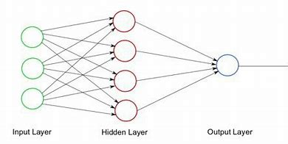

**CREATING AND TRAINING OF NETWORK**

**C**onvolutional neural networks (CNN) is the one of the major components of neural networks. It contain neurons with learning weights and prejudices. Every neuron receives multiple inputs and takes a weighted sum over them where it transmits an activation function and responds with an output again. The CNN usually depends on three layers, Convolutional Layer, Pooling Layer and Dense Layer (Fully Connected Neural Network). The neuron of the human brain and every neuron does some work. In the same way, the CNN layer has perform its contribution when it comes to classifying an image.**The image directly in the CNN instead of converting it into the 2D array or any standard dimension. The data we use for training, such as if we utilize some pictures of employee as training data, then CNN creates a filter based on the features (e.g. eyes, nose, ear, and so on) of each image that helps to detect an image. It is fast and simple to understand. It is the most accurate of all image predicting algorithms.** Since CNN has three layers (Convolutional Layer, Pooling Layer and Dense Layer)so let’s see how the Convolutional Layer works. **Convolutional Layer:**In convolutional neural networks, the main building blocks are convolutional layers. Convolutional Layer is the basic process of applying a filter to an input to produce an activation. As a consequence, extremely unique features appear on input images that can be identified anywhere. The CNN first create a filter based on all the features in the input images that allows for image detection. The pooling layer goal is to gradually shrink the spatial size of the representation in order to reduce the number of parameters and computation in the network. Each function map is treated individually by the pooling layer. There are two forms of pooling levels: average maximum pooling and maximum pooling, but maximum pooling is the most common. The pooling layer diminishes the parameters for which the overfitting of the model is decreased.

Each neuron in a layer receives information from all the neurons in the previous layer, making them densely connected. In other words, the dense layer is a completely connected layer, which means that all the neurons in a layer are connected to the next parts and the input image is classified through this layer. Next, we have to define activation functions like Sigmoid etc. The Activation function depends on data such as Softmax can be used for the case of multiclass classification and Sigmoid for binary classification.

* 1. SYSTEM ARCHITECTURE

3.31 BLOCK DIAGRAM

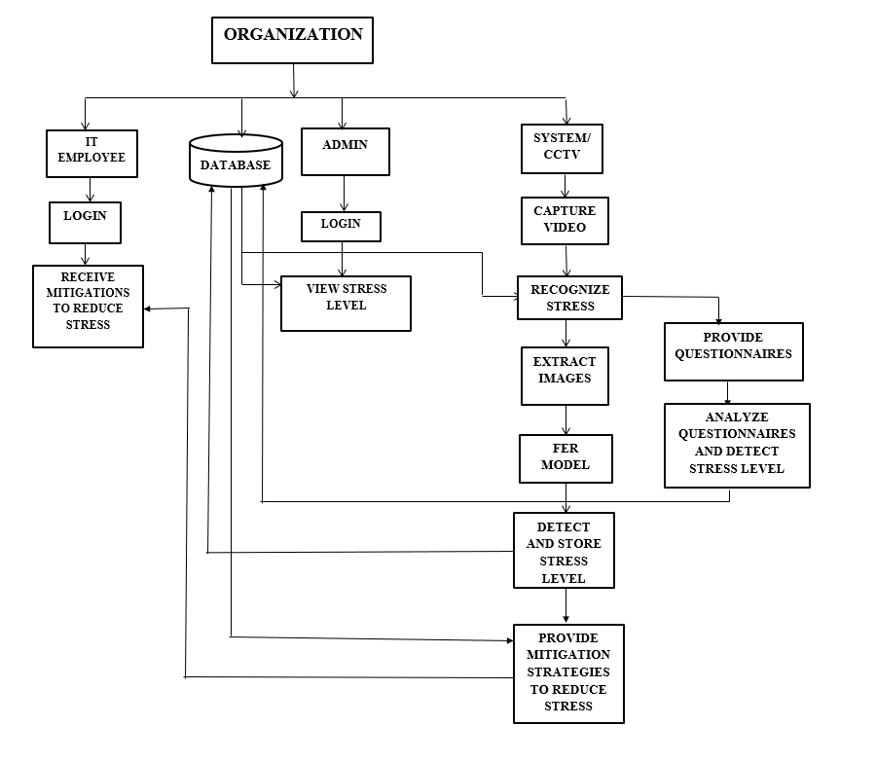

Fig 3.31 System Architecture

3.3.2 USECASE DIAGRAM

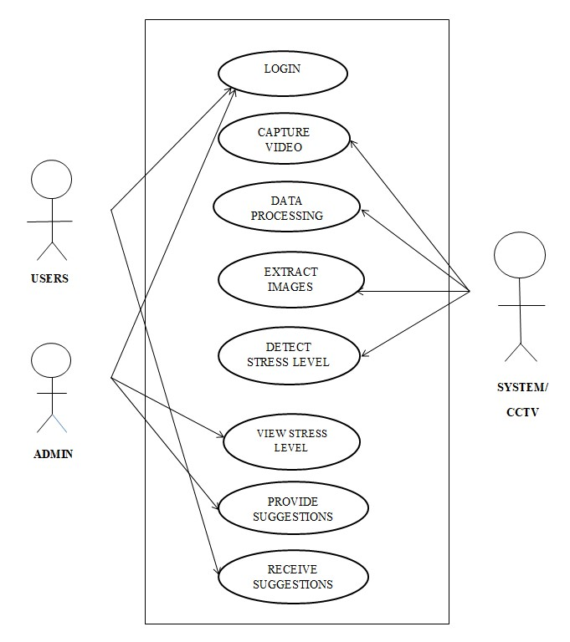

Fig 3.32 Use case Diagram

* + 1. **STEPS INVOLVED IN CONVERSION** **FOR RECOGNITION**
    2. **ACCURACY RESULTS**

Fig 3.34 accuracy Result

3.3.5 CONCLUSION

Thus the system architechture has been developed and verified

successfully.

# Introduction

**CHAPTER 4**

**System implementation**

Using Mini-xception in CNN the system will recognize the user input efficiently. The system or software can recognize by converting the video into images and it will converted into binary image it is more convenient to recognize and compare the user input and the trained dataset.

# Hardware and Software Requirements:

Hardware Requirements: Hardware :dual core Speed:2.80 GHz RAM:2GB

Hard disk: 500 GB

Key board: standard windows keyboard Mouse: two or three button mouse Moniter:SVGA

Input: Any kind of video file and converted into image file.

Software requirements:

Operating system: windows 10 Technology:python

IDE: Anaconda, flask, web designing languages.

Server: Apache HTTPD and nginx

# TECHNOLOGIES USED

**Mini-xception in CNN** is the most mainstream technique used for stress detection and reduction . This is done by capturing the video using webcam and then converting it into images. Then work with images and detect the person is stressed or not which is also predict the other emotions. **Front end:**

In this project, Html , CSS , python that can be moved into flask as a front end and also the cv2(Computer Vision) it is used to capture the video and convert them into the images.

# Back end:

In ML the CNN is used for stress detection and reduction using the emotion detection algorithm. In the system the python is work as a backend .

# Algorithms of overall process

Convolutional neural networks (CNN), usually simply called neural

networks (NNs), are computing systems vaguely inspired by the biological neural networks that constitute animal brains.

An CNN is based on a collection of connected units or nodes

called artificial neurons, which loosely model the neurons in a biological brain. Each connection, like the synapses in a biological brain, can transmit a signal to other neurons. An artificial neuron that receives a signal then processes it and can

21

signal neurons connected to it. The signal at a connection is a real number, and the output of each neuron is computed by some non-linear function of the sum of its inputs. The connections are called *edges*. Neurons and edges typically have

a *weight* that adjusts as learning proceeds. The weight increases or decreases the strength of the signal at a connection. Neurons may have a threshold such that a signal is sent only if the aggregate signal crosses that threshold. Typically, neurons are aggregated into layers. Different layers may perform different transformations on their inputs. Signals travel from the first layer (the input layer), to the last layer (the output layer), possibly after traversing the layers multiple times. In that the mini- Xception is used to know the emotion of the person i.e. sad, happy, angry, stress all kind of emotions can be analysed using the mini-Xception algorithm.

* 1. SNAPSHOTS OUTPUT

ORIGINAL IMAGE:

CONCLUSION:

Thus the output and original image are verified and implemented successfully.

# CHAPTER 5

**Performance analysis**

* 1. **Introduction**

Testing is performed to make sure that the system is reliable and produces the desired results considering the aim of the project.

# System testing

Testing is performed the user input or image for the system to be trained. Using the dataset the images are classified based on the percentage of impact. When an image is fed into the system through the image file into the mini-Xception algorithm. The image was resized into desired pixels for the system to act upon and then produces the result. The results produced are accurate to about 90% if the image is clear.

# Experimental testing

Experimental results show the promising accuracies of the system.

The experiments were carried out on images obtained from the user give an image The proposed system provides stress detection and reduction accuracy above 90%.

# Conclusion

The system aims at providing promising results with accuracy of up to 98 percent and works with any system that has the basic requirements needed for the system along with good quality image from the video.

# CHAPTER 6 CONCLUSION AND FUTURE WORK

* 1. **CONCLUSION**

Capturing the video and Classification of images and learning of image processing techniques is done in this project. Also the scheme through which project is achieved is **Convolutional Neural Network** scheme. The result which was got was correct up to more than 90% of the cases, but it would be improved at the end. This work was basically focused on stress management that can efficiently work the employee and make them healthy. The method I came up with gave efficient and effective result both for reduction and detection. There are also different methods through which ‘stress detection and reduction’ is achieved.

# FUTURE SCOPE OF THIS PROJECT

The application of this mini-Xception algorithm is extensive. Now-a-days recent advancement in technologies has pushed the limits further for man to get rid of older equipment which posed inconvenience in using. In our case that equipment is a webcam. Prioritize and gave the remedy to them. Though there is significant progress in the  identification of facial emotions in the past decade,  there are some outstanding issues and new avenues  exist for future development. Below, we propose  some potential research directions.

**Body posture**:

In addition to identifying stress  through facial emotions, one can develop it further to  identifying stress along with ones body posture  which provides much more accurate results.

**Explainable Facial-expression analysis**:

Although  machine learning methods have received increasing attention in the phase of facial emotion analysis and  achieved good performance in facial expression  analysis, these models are usually treated as  unexplainable as they have poor interpretability and  are hard to explain.

**Movement analysis**:

The extraction of facial  emotion heavily depends on the ability to detect  facial feature points, the semantic location of which  has been predefined. It is because the facial feature  point detection can reduce the effect caused by head  movement during pre-processing. It would therefore  be useful in the future to design an end-to-end model  capable of both learning the movement of face during  facial-emotion recognition and detecting facial  feature points. In this way, one could arrive at a more  accurate system.

# APPENDIX

**REFERENCES**

[1] Brindahini Vimaleswaran Andreoli, Gayashini  Shyanka Ratnayake “E - Therapy Improvement  Monitoring Platform for Depression using Facial  Emotion Detection of Youth” 2021 Third  International Conference on Intelligent  Communication Technologies and Virtual Mobile  Networks, March 2021.

[2] Mohammad Rami Koujan , Luma Alharbawee ,  Giorgos Giannakakis , Nicolas Pugeault , Anastasios  Roussos “Real-time Facial Expression Recognition  In The Wild by Disentangling 3D Expression from  Identity” ,18 January 2021.

[3] Abhishek Verma, Piyush Singh, John Sahaya  Rani Alex “Modified Convolutional Neural Network  Architecture Analysis for Facial Emotion  Recognition”, August 2019.

[4] Yue Lu, Xinsha Fu, Enqiang Guo, Feng Tang  "XGBoost Algorithm-BaseMonitoring Model for  Urban Driving Stress: Combining Driving Behaviour,  Driving Environment, and Route  Familiarity", January 2021.

[5] Xianye Ben, Yi Ren, Junping Zhang, Su-Jing  Wang, Kidiyo Kpalma, Weixiao Meng, Yong-Jin  Liu “Video-based Facial Micro-Expression Analysis:  A Survey of Datasets, Features and Algorithms”,  March 2021.

[6] Giorgos Giannakakis1, Mohammad Rami  Koujan2, Anastasios Roussos and KostasMarias ”  Automatic stress detection evaluating models of  facial action units” 15th IEEE International  Conference on Automatic Face and Gesture  Recognition, January 2021**.**

[7] Wheidima Carneiro de Melo, Eric Granger, Sensors in Everyday Settings” 43rd Annual  International Conference of the IEEE Engineering in  Medicine & Biology Society, December 2021.

[8] Ali Tazarvk, Sina Labbaf, Stephanie M. Reichy,  Nikil Dutt, Amir M. Rahmaniz, Marco Levorato  “Personalized Stress Monitoring using Wearable bdenour Hadid “A Deep Multiscale Spatiotemporal  Network for Assessing Depression from Facial  Dynamics” IEEE Transactions on Affective  Computing, September 2020.

[9] Ryota Mitsuhashi, Kaito Iuchi,, Takashi Goto,  Akira Matsubara, Takahiro Hirayama, Hideki  Hashizume, Norimichi Tsumura “Video-Based Stress  Level Measurement Using Imaging  Photoplethysmography” IEEE International  Conference on Multimedia & Expo  Workshops, August 2019.

[10] Gen-Min Lin,Masanori Nagamine,Szu-Nian  YangYueh-Ming Tai,Chin Lin,Hiroshi Sato  "Machine Learning Based Suicide Ideation  Prediction for Military Personnel" 2021 IEEE Journal  of Biomedical and Health Informatics April 2020.

[11] S. Kumar D. Varshney G. Dhawan and H.  Jalutharia "Analysing the Effective Psychological  State of Students using Facial Features" 2020 4th  International Conference on Intelligent Computing  and Control Systems (ICICCS) May 2020.

[12] Daniela Girardi, Filippo Lanubile, Nicole  Novielli, Alexander Serebrenik “Emotions and  Perceived Productivity of Software Developers at the  Workplace” IEEE Transactions in  software Engineering, June 2021.

[13] Alberto Greco, Gaetano Valenza1, Jes´us  L´azaro, Jorge Mario Garz´on-Rey, Jordi Aguil,  Concepcion de la C´amara6, Raquel Bail´on, and  Enzo Pasquale Scilingo “Acute stress state  classification based on electrodermal activity  modelling” IEEE Transactions on Affective  Computing , January 2021.

[14] Pasquale Arpaia, Nicola Moccaldi, Roberto  Prevete, Isabella Sannino, Annarita Tedesco” A wearable EEG instrument for real-time frontal asymmetry monitoring in worker stress analysis”  IEEE Transactions on Instrumentation and  Measurement, April 2020.

[15] Cristina Bustos, Neska Elhaouij, Albert Sol´e Ribalta, Javier Borge-Holthoefer, Agata Lapedriza,  and Rosalind Picard” Predicting Driver Self-Reported  Stress by Analyzing the Road Scene” 2021 9th  International Conference on Affective Computing  and Intelligent Interaction (ACII), November 2021.